**OUTPUTS:**

1)

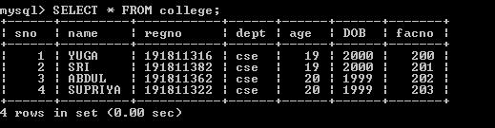

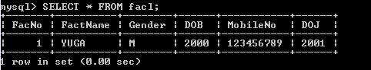

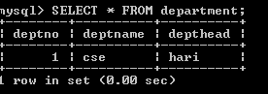

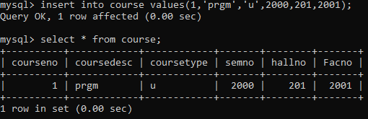

2)



3)



4)

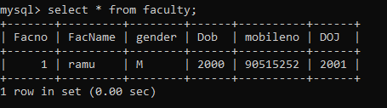

5)

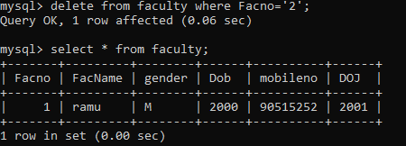

6)

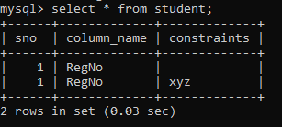

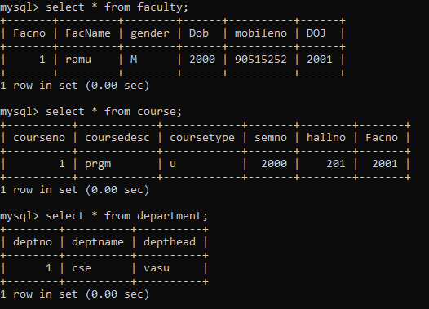

**RESULT**:

Data Manipulation Language (DML) Commands such as INSERT, SELECT, UPDATE, DELETE are performed in the five tables.